Is Drinking Alcohol Harmless?
by Harry Osborne

The following article is one that should be considered by those who think alcohol is harmless:

Alcohol is killing Americans at a rate not seen in at least 35 years, according to new federal data. Last year, more than 30,700 Americans died from alcohol-induced causes, including alcohol poisoning and cirrhosis, which is primarily caused by alcohol use.
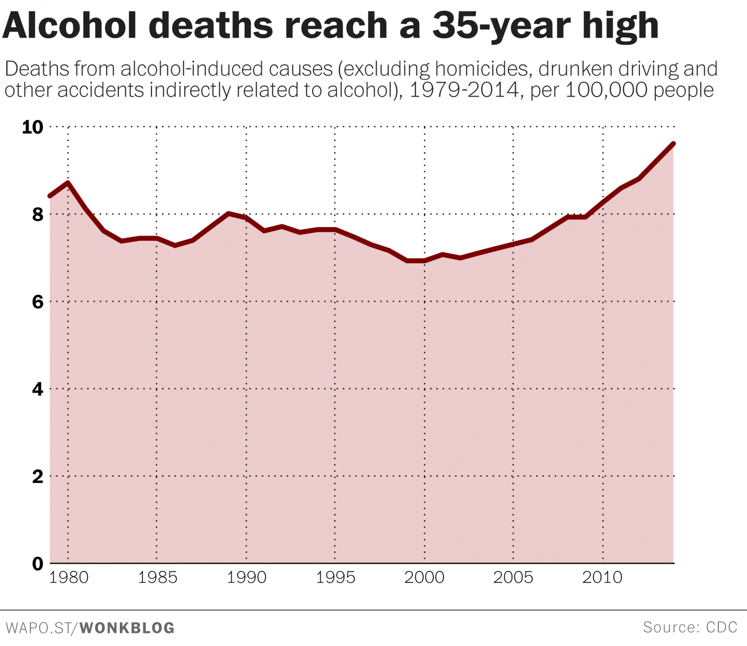
In 2014, there were 9.6 deaths from these alcohol-induced causes per 100,000 people, an increase of 37 percent since 2002.

This tally of alcohol-induced fatalities excludes deaths from drunk driving, other accidents, and homicides committed under the influence of alcohol. If those numbers were included the annual toll of deaths directly or indirectly caused by alcohol would be closer to 90,000, according to the Centers for Disease Control and Prevention.
In recent years, public health experts have focused extensively on overdose deaths from heroin and prescription painkillers, which have risen rapidly since the early 2000s. But in 2014, more people died from alcohol-induced causes (30,722) than from overdoses of prescription painkillers and heroin combined (28,647), according to the CDC.
Philip J. Cook, a Duke University professor who studies alcohol consumption patterns and their effects, notes that per-capita alcohol consumption has been increasing since the late 1990s.
"Since the prevalence of heavy drinking tends to follow closely with per capita consumption, it is likely that one explanation for the growth in alcohol-related deaths is that more people are drinking more," he wrote in an email.
The number of American adults who drink at least monthly rose by a small but significant amount between 2002 and 2014 -- from 54.9 percent to 56.9 percent -- according to data from the Substance Abuse and Mental Health Services Administration. The change has been especially pronounced among women. The percent of women drinking monthly or more rose from 47.9 in 2002 to 51.9 in 2014. And the percentage of women reporting binge drinking -- defined as five or more drinks on at least one occasion -- rose from 15.7 to 17.4 percent over the same period.
Cook notes that when you adjust the alcohol fatality rates for age, the increase narrows somewhat. That's because older Americans are at more risk for alcohol-induced diseases, like cirrhosis, and the American population has gotten older over the past several decades. Once you adjust for age, the increase in alcohol-deaths "could plausibly be accounted for by the growth in per capita consumption," Cook said.
The heaviest drinkers are at the greatest risk for the alcohol-induced causes of mortality charted above. And some drinkers consume plenty of alcohol indeed. Prior research by Cook indicates that the top 10 percent of American adults consume the lion's share of alcohol in this country -- close to 74 drinks a week on average…
A recent study quantified the risk of death associated with the use of a variety of common recreational drugs. They found that at the level of individual use, alcohol was the deadliest substance, followed by heroin and cocaine. The reason? The ratio between a toxic dose and a typical dose is extremely narrow with alcohol. If you're happily buzzed at say, three drinks, three more might make you sick, and three after that may put you in alcohol poisoning territory.
Yes, alcohol is a killer – it is not harmless! For this reason, public health officials are urging greater concern about the danger of using alcohol, but their warnings today will do no more to end the problem than they have in the past. Their alarm focuses on the “heaviest drinkers” while accepting moderate use as non-problematic. It is the old appeal to drink intoxicants (which take away one’s clarity of mind to function rationally), but do so “responsibly.” The message is self-defeating! However, they totally overlook the greatest harm of alcohol. It’s greatest danger is not to the body, but to the soul!
Let us examine what real “wisdom” advises about drinking intoxicants. Proverbs is one of the books called “Wisdom Literature” in the Old Testament. The book of Proverbs begins with these words:
The proverbs of Solomon the son of David, king of Israel: to know wisdom and instruction, to perceive the words of understanding, to receive the instruction of wisdom, justice, judgment, and equity; to give prudence to the simple, to the young man knowledge and discretion— a wise man will hear and increase learning, and a man of understanding will attain wise counsel, to understand a proverb and an enigma, the words of the wise and their riddles. The fear of the LORD is the beginning of knowledge, but fools despise wisdom and instruction (Prov. 1:1-7).
Since we know Solomon was wise and that he was inspired by the All-Wise God to write the proverbs, let us see what those proverbs advise about the use of intoxicants:
Wine is a mocker, strong drink is a brawler, and whoever is led astray by it is not wise (Prov. 20:1).
Do not look on the wine when it is red, when it sparkles in the cup, when it swirls around smoothly; at the last it bites like a serpent, and stings like a viper. Your eyes will see strange things, and your heart will utter perverse things. Yes, you will be like one who lies down in the midst of the sea, or like one who lies at the top of the mast, saying: "They have struck me, but I was not hurt; they have beaten me, but I did not feel it. When shall I awake, that I may seek another drink?" (Prov. 23:31-34).
Did you catch that advice? “Do not look on the wine.” In other words, do not even view it with desire, much less drink it! Why? According to the wise Solomon, inspired by God, it will harm you in the end. That fact is noted after his advice, just as he had already stated in his preceding words:
Who has woe? Who has sorrow? Who has contentions? Who has complaints? Who has wounds without cause? Who has redness of eyes? Those who linger long at the wine, those who go in search of mixed wine (Prov. 23:29-30).
If you are seeking true wisdom in advice concerning intoxicants, there you have it! The Bible still retains the wise advice needed to truly correct the problem: DO NOT EVEN LOOK ON IT!

