Preaching Trips to the Philippines
by Harry Osborne

Since coming here to labor with the 84th Street congregation, you have been an important part in spreading the gospel to the Philippine Islands. This year completes 15 years for me of being involved with preaching efforts in the Philippines. The congregation has provided a significant part of the finances needed in each trip since 2005. Not only has the church had fellowship in the work through the support provided through the treasury, but many individuals have given generously to help make this work possible. Please know that I am deeply grateful to each one for the help provided. Without your help, we would not have been able to rejoice together over the abundant harvest of souls for the Lord’s service that has occurred.

The abundance of that harvest has been beyond my wildest expectations. Yes, there has been a multitude of baptisms. Just as in this country, it is always a joy beyond words to see a new life in Christ begin! However, that is not the only measure of that harvest. Early in my work in the Philippines, doors were opened to hold lectures designed for preachers from various denominations willing to study with us. Many of them have responded to invitations for open study of God’s word and have renounced human error to obey the simple truth of our Lord. Scores of congregations now exist in several regions of the country where few or none existed a few years ago. Open doors are constantly presented promising even more opportunities!

With this great harvest of souls, an enormous need for edifying those who have obeyed the gospel has arisen. Yet, it is shortsighted to merely teach people the first principles of the gospel without working to strengthen their faith that they might grow to maturity. The bulk of that task must lie with Filipino brethren and they are constantly fulfilling the challenge. I receive many reports every month from Filipino preachers who are tireless in their efforts across that nation to further evangelize the lost and edify the saints. However, we can be of help in that effort.

While they seek to help others grow, a great challenge exists with many of those preachers who have come out of denominationalism. Having grown up with denomination error and misuse of Scripture, they have much to unlearn and overcome. The vast majority of those preaching the gospel in the Philippines came out of denominations. Several years ago, I saw the need for having in-depth studies of Bible books in order to give these brethren practical experience in exegesis of the text and specific application of its teaching. Subject studies covering topics need and specific refutation of denominational errors are also needed. Much prayer and thought was directed towards how to wisely meet this need.

Jonathan Carino, Lordy Salunga and several other Filipino brethren discussed with me the fact that those coming out of denominations had little knowledge in how to study the Bible. We all agreed that a depth of understanding the text of Scripture was the way to help these brethren grow and deepen their faith. We decided it would be best to work with those who were able to understand English well so that they could take the lessons learned to others in their own dialects (cf. 2 Tim. 2:2). Jonathan Carino, who this church helps to support, agreed to work with me in such classes by inviting men to Cebu City for a week of all-day studies on the book of Hebrews. By “all-day studies,” I mean classes that started at 7:30am and went to 5pm with only a one-hour break for lunch and two short breaks during the morning and afternoon sessions. There was also homework each evening to make sermon outlines out of the part of the text studied during the day’s studies. It was a very packed schedule that was very demanding on the students – so demanding that I was not sure how it would be received by the men invited.

At the end of the week, the classes were more successful than we had ever hoped! The men present were excited by the opportunity to study and learn in this intensive way and asked for more studies of other books. Their outlines each night showed an amazing level of growth in understanding and ability to organize thought for presentation to others. News of the studies spread to other brethren from across the Philippines and we were swamped with requests from those asking for the opportunity to attend such studies in the future. So, we arranged a second study in Cebu on the book of Romans and invited several more men to come and study for the week. It also was very successful, but even more brethren from allover the country were asking to take part in the studies.

During this same period, the topics of Premillennialism and Fellowship became topics of needed study. A man from so-called “premillennial churches of Christ” started to associate with faithful brethren. Some claimed that he had “renounced” his former advocacy of Premillennialism. However, it became obvious that he not only still held to that error, but started to advocate a “fellowship” that would include faithful brethren working together with those advocating Premillennialism, Institutionalism, instrumental music in worship and a variety of other unity-in-diversity concepts. Some Americans going to the Philippines have been pushing the same agenda with increasing fervor. This has resulted in confusion and some departures from the truth. Jonathan Carino, Lordy Salunga, Rody Gumpad and others all suggested that in-depth classes were urgently need on these subjects. However, we also wanted to keep the textual studies on Bible books going as they help brethren develop the tools for examining the Scripture as the sole basis for our faith and practice. Thus, we agreed to have two full week classes for this Fall – one in Cebu and another in the Manila area. The remaining days of each trip will be used to edify brethren in established congregations and help reach those outside of Christ with Gospel meetings in various areas across the country.

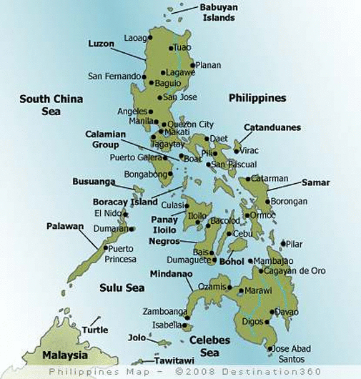
The Lord willing, the first of these two Fall trips will begin this Tuesday. After flying to Manila, I will go on to Cebu on Friday. On Saturday (Sept. 3), a Gospel meeting has been planned by the brethren that meet in the central part of that very large city. I will be preaching with area congregations on Sunday and men will start arriving for the classes later that day. The classes on the Epistles of Peter and Premillennialism will be held Monday through Friday (Sept. 5-9). Early on Saturday morning, I will fly to Bacolod and work with the brethren there on Saturday through Monday (Sept. 10-12). The Lord willing, I will then return to Manila for some work on logistics for the next trip and a day of rest before returning home on Thursday, September 15.

Please keep this work on your prayers! As always, I provide daily reports on the work done through email updates as well as my blog (harryosborne.blogspot.com) that has pictures along with the report. May God bless all of us in our work for His kingdom!

